**MINI PROJECT REPORT**

**on**

**ARDUINO BASED HOME AUTOMATION**

**USING TV REMOTE**

**BACHELOR OF TECHNOLOGY**

**(Computer Science and Engineering)**

***by***

**B.S.L.PRASANNA (18NM1A0518)**

**A.VYSHNAVI (18NM1A0504)**

**K.DAKSHAYANI (18NM1A0556)**

**B.JYOSHNA (18NM1A0511)**

*Under the guidance of*

**Mrs.D.KIRANMAYI**

**Assistant Professor**



**DEPARTMENT OF COMPUTER SCIENCE & ENGINEERING**

**VIGNAN’S INSTITUTE OF ENGINEERING FOR WOMEN**

(Affiliated to Jawaharlal Nehru Technological University,Kakinada)

Kapujaggarajupeta, Vadlapudi Post, Visakhapatnam, Andhra Pradesh.

**2022**

**VIGNAN’S INSTITUTE OF ENGINEERING FOR WOMEN**

(Affiliated to Jawaharlal Nehru Technological University,Kakinada)

Kapujaggarajupeta, Vadlapudi Post, Visakhapatnam, Andhra Pradesh.

**DEPARTMENT OF COMPUTER SCIENCE & ENGINEERING**



**CERTIFICATE**

This is to certify that the mini project report titled **“ARDUINO BASED HOME AUTOMATION USING TV REMOTE”** is being submitted to Department of CSE by **B.S.L.PRASANNA (18NM1A0518), A.VYSHNAVI (18NM1A0504), K.DAKSHAYANI (18NM1A0556) and B. JYOSHNA (18NM1A0511)** during the study of IV B.Tech I Semester of **Bachelor of Technology** in **COMPUTER SCIENCE & ENGINEERING** during the period December 2021 – February 2022.

|  |  |
| --- | --- |
| **Mini Project Guide** | **Head of the Department** |

**DECLARATION**

We hereby declare that this project entitled **ARDUINO BASED HOME AUTOMATION USING TV REMOTE** submitted as mini project during IV B Tech I Semester of **Bachelor of Technology** in **Computer Science & Engineering** is the original work done under the guidance of **Mrs.D.KIRANMAYI Assistant Professor**, Department of Computer Sciene & Engineeering, Vignan’s Institute of Engineering for women, Visakhapatnam.

**B.S.L.PRASANNA(18NM1A0518)**

**A.VYSHNAVI (18NM1A0504)**

**K. DAKSHAYANI (18NM1A0556)**

**B. JYOSHNA (18NM1A0511)**

**ACKNOWLEDGEMENT**

We express our sincere indebtedness towards our guide **Mrs.D.KIRANMAYI Assistant Professor**, department of Computer Science & Engineering, VIEW for his invaluable guidance, suggestions and supervision throughout the work. Without his kind patronage and guidance, the mini project would not have taken shape. We would also like to express our gratitude and sincere regards for his kind approval of the mini project, time to time counseling and advices.

We would also like to thank to Dr. K. Vijaya Kumar, Associate Professor and Head of the Department, Department of Computer Science & Engineering, VIEW for his expert advice and counseling from time to time.

We owe sincere thanks to all the faculty members in the Department of Computer Science & Engineering for their kind guidance and encouragement from time to time.

**B.S.L.PRASANNA(18NM1A0518)**

**A.VYSHNAVI (18NM1A0504)**

**K. DAKSHAYANI (18NM1A0556)**

**B. JYOSHNA (18NM1A0511)**

**ABSTRACT**

This provides remote controlling and automation for homes and offices.These are very essential in present life style. Wireless control is primary concern for everyone. This describes a design of effective remote control system that can monitor the house. Apart from remote control concern here we also take care of home automation. This gives the best solution for electrical power wastage. The home appliances are switched on/off using IR without actually going near to the switch boards or regulators. The water level of the tank can also be monitored and the motor can be controlled through automation.

**CONTENTS**

**DECLARTIONS**

**ACKNOWLEDGEMENT**

**ASTRACT**

**LIST OF FIGURES**

**LIST OF ABBREVIATIONS**

**Chapter 1: INTRODUCTION**

1.1: Introduction

1.2: Background

**Chapter 2: PROBLEM STATEMENT**

2.1: Problem statement

2.2: Aims and objectives

2.3: Literature review

**Chapter 3: SYSTEM ANALYSIS**

3.1: System analysis

3.2: Problem specifications

3.3: Existing System

3.4: Proposed System

**Chapter 4: ABOUT THE PROJECT**

4.1: About the project

4.2: Requirements & Specifications

4.3: System Implementation

4.3.1: Software description

4.3.2: Project description

**Chapter 5: CODING**

5.1: Sample code

**Chap43.ter 6: OUTPUT**

6.1: Output Screens

**Chapter 7: CONCLUSION**

7.1: Conclusion

7.2: Future Scope

7.3: References

**LIST OF ABBREVIATIONS**

**ARDUINO UNO**

UNO forms the main controlling part of the circuit. UNO has 13 digital I/O pins and hence, it is possible to control 13 different devices at once. If the requirement is to control more number of devices, boards like [Arduino Mega](https://www.electronicshub.org/arduino-mega-pinout/) can be used.

**TSOP1738**

TSOP1738 is a Receiver module for IR Remote controls with a carrier frequency of 38 KHz. It consists of a Photo detector and signal demodulator in a single package and the output can be directly used by a microcontroller.

**4 – Channel Relay Board**

A Relay helps in controlling a large appliance with the help of a microcontroller. In this project, a 4 – channel relay board is used to control four loads.

The necessary components like power on LED, switching transistor, base current limiting resistor, Relay on LED, flyback diode and male headers for power and input connections are already embedded on the board.

**Caution**

We should be very careful when using a relay with AC mains supply.

**Remote Control**

A standard mini remote control is used in this project to give the various key inputs. The remote has all the numeric keys, volume up – down, channel up – down, menu and some additional keys.

**CHAPTER 1**

**INTRODUCTION**

**1.1 INTRODUCTION**

Arduino based Home Automation using TV Remote is a simple project ,where an old TV Remote is used to control different appliances.

Home Automation is a concept where a single device is used to control many aspects of a home like switching on and off different appliances, monitoring temperature, fire alarms, garage doors etc. In this project, a remote control is used to control (simply ON and OFF) several appliances or devices, thus achieving a simple home automation system.

Home automation makes life more convenient and can even save you money on heating, cooling and electricity bills. Home automation can also lead to greater safety with Internet of Things devices like security cameras and systems.

Remote controls are one of the commonly found devices in almost all homes. They help us operating an appliance like TV, Air Conditioning, VCR, etc. The main feature of a remote control is that it is specific to a device. For example, a TV remote control unit can only be used for that corresponding TV.

But in this project, we have designed an Arduino based Home Automation using TV Remote, where a single remote is used to control 4 different devices (possible to control more devices). The project is based on Arduino UNO and more details of the project are mentioned below.

**1.2 BACKGROUND**

The main component of the project is the TSOP1738 receiver. It is a three pin device where the three pins are GND, VS and OUTPUT. The VS pin is connected to the 5V supply. The output pin is connected to Pin 11 (or any other digital pin) of Arduino UNO.

We are using a 4 – channel relay module in this project in order to control 4 different loads. Since the board has all the necessary components like transistors, LEDs etc. all we need to do is to connect the 4 inputs on the relay board to 4 digital I/O pins of Arduino. More detailed connection can be found in the circuit diagram.

**CHAPTER 2**

**PROBLEM STATEMENT**

**2.1 PROBLEM STATEMENT**

Home automation is an in demand concept where a single device will control different appliances of a home. Additionally, different aspects like temperature, humidity, security etc. can also be monitored using that device.

In this project, a simple home automation system where the system controls 4 different appliances with the help of a TV Remote. The working of the project is explained here.

The main component of the project is TSOP1738 IR Receiver Module. This module has a built – in photo receiver, band pass filter and demodulator and the output of the module can be readily read by a microcontroller.

TSOP1738 supports a carrier frequency of 38 KHz. Hence, the carrier frequency of the source i.e. the remote control must be in the range of 38 KHz for it to demodulate.

First, we will decode the data from the remote control using TSOP1738 and Arduino UNO. For that, we need to use a special library called “IRremote”. We need to download this library from https://github.com/z3t0/Arduino-IRremote and place it in the libraries folder of Arduino.

The next step is to decode the data of each key of the remote. For this, we are going to use some functions in the “IRremote” library. The following program will help us in decoding the data from each key of the remote.

Before the invention of home appliances controlled by TV remote, it was difficult to physically handicapped and old turn person to ON/Off the electrical appliances by going towards the switch board. Also, sometimes we forgot to switch OFF all switches in home when we leave from home, so there is wastage of electricity. Hence to reduce the efforts and to save electricity, we have designed this system. In that we can switch ON/OFF any electrical appliances by sitting at one place using TV remote

**2.2 AIMS AND OBJECTITIVES**

The main aim and objective of this project is where a single device can control different appliances of a home. Additionally ,different aspects like temperature ,humidity etc. The unused buttons in a single device can be used to operate other electrical devices. Since wireless communication is the primary concern every one, the main objective of the project would satify their needs.

# 2.3 LITERATURE REVIEW

# In remote based home automation system the home appliances are connected to the Arduino UNO board at input output ports using relay module. The program of Arduino UNO board is based on high level interactive programming language of microcontrollers; the connection is made via remote. The password protection is provided so only authorized user is allowed to access the appliances. The remote connection is established between Arduino UNO board and tv remote for wireless communication. In this system the code is used and it can install on any of the Symbian OS environment, it is portable. One circuit is designed and implemented for receiving the feedback from the remote, which indicate the status of the device.

# CHAPTER 3

# SYSTEM ANALYSIS

**3.1** **SYSTEM ANALYSIS**

It is a process of collecting and interpreting facts, identifying the problems, and decomposition of a system into its components.

System analysis is conducted for the purpose of studying a system or its parts in order to identify its objectives. It is a problem solving technique that improves the system and ensures that all the components of the system work efficiently to accomplish their purpose.

**3.2 PROBLEM SPECIFICATION**

Home automation is incredible. It can make almost all aspects of your home simpler, more comfortable and more enjoyable. How ever you live at home, it can dramatically enhance your home living experience.

Home automation, though, is much less exceptional when it goes wrong. And, unfortunately, due to things like poorly integrated sub systems, inadequate functionality, and installation delays, home automation problems can arise. Here are few such problems and how we can solve them.

Today, it has never been easier or more affordable to purchase and install smart devices and home automation systems. This is a good thing. The drawback, however, is that systems are regularly being installed incrementally without a central control point. And that can lead to home automation problems.

Without an understanding of how smart devices communicate, home owners regularly install units which can only  be controlled by the manufacturer's app. This means that after installing several devices, the home owner's smartphone can be swamped with multiple apps, all controlling different devices and all dedicated to controlling the home under normal living conditions.

A better way is to install a dedicated, all-in-one control point.You can achieve this by asking your ITA home automation specialist about developing a master plan prior to purchasing your first device or system. Or by discussing alterations to your existing system.

**3.3 Existing System**

Security ,tap your finger to turn on the lights when get home so you worried about What’s hiding in the shadows. Or in your pathways. Or automate to turn on when You are not home to look like you are to ward off potential robbers. Door lacks are another automated home product that increase your home security.

Energy Efficiency Increase your home energy efficiency by remotley powering off systems and appliances when they aren’t in use. In addition to the standard home automation Products that give you active control. Some products actively monitor systems and arm the homeowner with knowledge. Insight and guidance to greater control and energy efficiency.

Saving Home automation literally pays off. When you are use home systems and appliances only when needed. The saving will apparent in the first Utilty bill. No more wasting money on lights left on when you are not home.

## 3.4 Proposed System

## 1.Security Tap your finger to turn on the lights when get home so you worried about What’s hiding in the shadows. Or in your pathways. Or automate to turn on when You are not home to look like you are to ward off potential robbers. Door lacks are another automated home product that increase your home security.

## 2. Energy Efficiency Increase your home energy efficiency by remotley powering off systems and appliances when they aren’t in use. In addition to the standard home automation Products that give you active control. Some products actively monitor systems and arm the homeowner with knowledge. Insight and guidance to greater control and energy efficiency. 3. Saving Home automation literally pays off. When you are use home systems And appliances only when needed. The saving will apparent in the first Utilty bill. No more wasting money on lights left on when you are not home.

## 3.Energy Efficiency Increase your home energy efficiency by remotley powering off systems and appliances when they aren’t in use. In addition to the standard home automation Products that give you active control. Some products actively monitor systems and arm the homeowner with knowledge. Insight and guidance to greater control and energy efficiency. Saving Home automation literally pays off. When you are use home systems And appliances only when needed. The saving will apparent in the first Utilty bill. No more wasting money on lights left on when you are not home.

## Fig : The Figure below is the flow chart of the proposed model

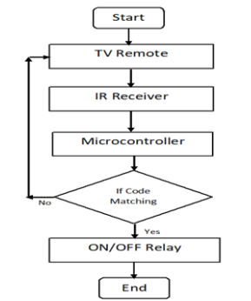

**CHAPTER 4**

## ABOUT THE PROJECT

**4.1 ABOUT PROJECT**

This project is one of the important Arduino Projects. Arduino based home Automation using remote project helps the user to control any electronic Device using remote . The remote sends commands to controller- Arduino . The android Sends commands to the controller-Arduino through wireless communication, Namely, remote . The Arduino is connected to the main Relay module as shown in the block diagram, Device 1- for on and off of the one of the home appication, Device 2- for on and off of another home appication . When the user presses on the On button displayed on the remote for the device is switched on. The device can be switched off, by pressing the same Button again .

# 4.2 REQUIREMENTS & SPECIFICATIONS

# By using remote we can operate the home appliance, we used the same button to switch on the home appliance and the same button to switch off the home appliance.

# 4.3 SYSTEM IMPLEMENTATION

## 4.3.1 SOFTWARE DESCRIPTION

Arduino Uno is a microcontroller board based on the ATmega328P (datasheet). It has 14 digital input/output pins (of which 6 can be used as PWM outputs), 6 analog inputs, a 16 MHz quartz crystal, a USB connection, a power jack, an ICSP header and a reset button. It contains everything needed to support the microcontroller; simply connect it to a computer with a USB cable or power it with a AC-to-DC adapter or battery to get started.. You can tinker with your UNO without worring too much about doing something wrong, worst case scenario you can replace the chip for a few dollars and start over again.

"Uno" means one in Italian and was chosen to mark the release of Arduino Software (IDE) 1.0. The Uno board and version 1.0 of Arduino Software (IDE) were the reference versions of Arduino, now evolved to newer releases. The Uno board is the first in a series

of USB Arduino boards, and the reference model for the Arduino platform; for an extensive list of current, past or outdated boards see the Arduino index of boards.

**4.3.2 PROJECT DESCRIPTION**

Initially , the main theme of the project is to operate the electronic devices using a single a device. In this project initially we will decode the unused keys of the remote to operate the electronic devices. Then we will pass the signals from remote to the Ir receiver which will receive the signals and pass to the relay module with the help of aurdino .by connecting wires to the respective output pins we can see the output. The respective connection are to be made while connecting the Relay module to the aurdino is we need to connect grnd to grnd ,vcc to 5v and input1 to 2 ,input2 to 3 ,input3 to 4 and while connecting the IrReceiver to the aurdino the following connections are to be made output to 11,vcc to 3.3v and grnd to grnd. By connecting all these connections we can operate tv, fans, light etc depends upon the number of keys we decode.

**CHAPTER 5**

**CODING**

**5.1 SAMPLE CODE FOR DECODING THE VALUES OF EACH KEY IN THE REMOTE.**

#include <IRremote.h>

int RECV_PIN = 11;

IRrecvirrecv(RECV_PIN);

decode_results results;

void setup()

{

Serial.begin(9600);

irrecv.enableIRIn();

}

void loop()

{

if (irrecv.decode(&results))

{

Serial.println(results.value, HEX);

irrecv.resume();

}

delay(100);

}

**5.2 IMPLEMENTATION OF THE CODE**

#include <IRremote.h>

constint RECV_PIN=11;

IRrecvirrecv(RECV_PIN);

decode_results results;

#define IN1 3

#define IN2 4

#define IN3 5

#define IN4 6

bool i=false;

bool j=false;

bool k=false;

bool l=false;

bool m=false;

void setup()

{

Serial.begin(9600);

pinMode(IN1, OUTPUT);

pinMode(IN2, OUTPUT);

pinMode(IN3, OUTPUT);

pinMode(IN4, OUTPUT);

irrecv.enableIRIn();

irrecv.blink13(true);

}

void loop()

{

if (irrecv.decode(&results))

{

Serial.println(results.value,HEX);

delay(100);

if(results.value==0x40BD00FF)

{

i=!i;

digitalWrite(IN1, i);

}

if(results.value==0x40BD807F)

{

j=!j;

digitalWrite(IN2, j);

}

if(results.value==0x40BD40BF)

{

k=!k;

digitalWrite(IN3, k);

}

if(results.value==0x40BDC03F)

{

l=!l;

digitalWrite(IN4, l);

}

if(results.value==0x40BD28D7)

{

m=!m;

digitalWrite(IN1, m);

digitalWrite(IN2, m);

digitalWrite(IN3, m);

digitalWrite(IN4, m);

}

irrecv.resume(); // Receive the next value

}

}

# CHAPTER 6

# OUTPUT

**6.1 OUTPUT SCREEN**

## Fig : The Figure below shows the hexadecimal values of each key of the TV Remote

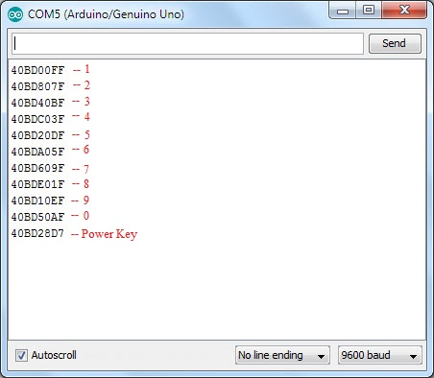

# 6.2 MODEL

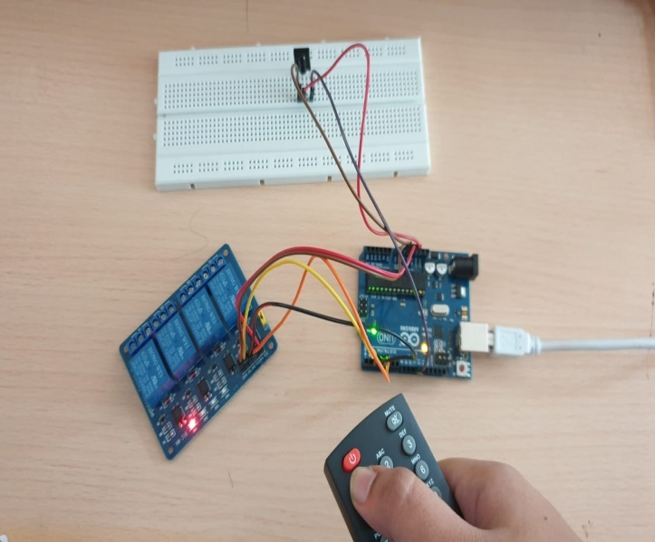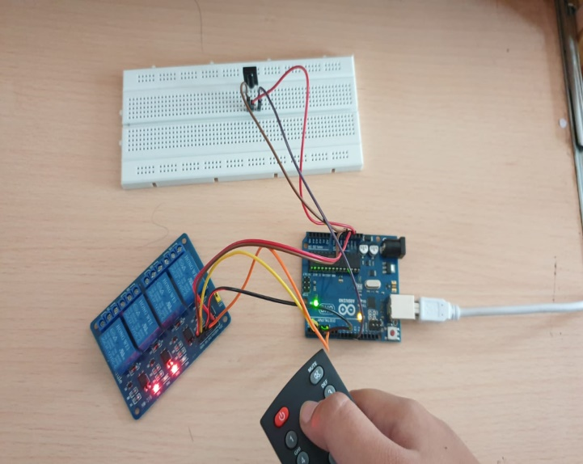

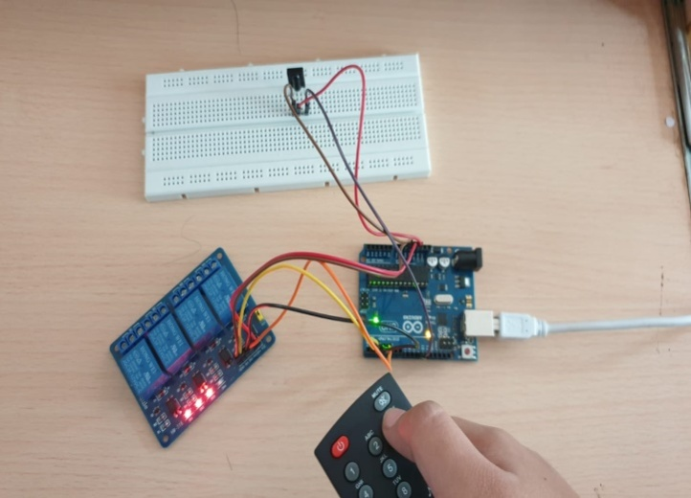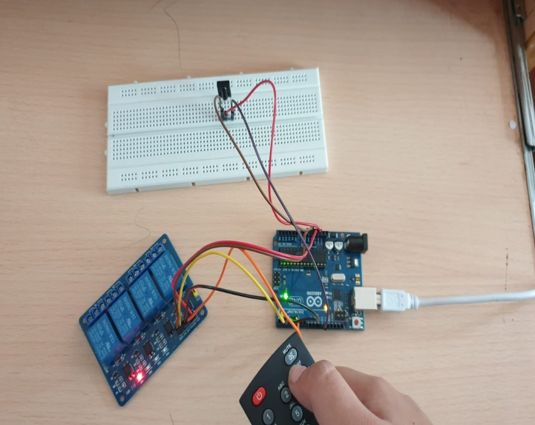

**CHAPTER 7**

**CONCLUSION**

**7.1 CONCLUSION**

In this project , we have introduced the event of a home management using remote and internet of things technology. The system is suitable for remotely controlling the home appliances. A smart home system integrates various electrical appliances in a home with each other using information devices automatically according the users need. For the web application the coding part is provided inside the program thus it doesn’t require any other application to be developed for different gadgets. The automated mode makes life easier for users by complete automation of necessary appliances without any human effort.

**7.2 FUTURE SCOPE**

Future scope for the home automation systems involves making homes even smarter. Homes can be interfaced with sensors including motion sensors, light sensors and temperature sensors and provide automated toggling of devices based on conditions. More energy can be conserved by ensuring occupation of the house before turning on devices and checking brightness and turning off lights if not necessary. The system can be integrated closely with home security solutions to allow greater control and safety for home owners. The next step would be to extend this system to automate a large scale environment, such as offices and factories. Home Automation offers a global standard for interoperable products. Standardization enables smart homes that can control appliances, lighting, environment, energy management and security as well as the expandability to connect with other networks.

**7.3 REFERENCES**

**https://randomnerdtutorials.com/arduino-ir-remote-control/**

13­­

9

11